
a
Company
Logotype

Cone Beam Computed Tomography- Report



Porur Dental X-rays & CBCT

Patient Name : Mr. Karthick | Date of Report : 08.05.2024
Age/ Gender : 30 years/ Male | Region of Interest : CBCT Maxilla
Referring doctor: Dr. Priyadarshini | Indication : Implant assessment
Clinical Notes: Nil
PATIENT INFORMATION

CBCT- Maxilla provided
CBCT – IMAGE DETAILS

RADIOGRAPHIC INTERPRETATION

- Completely missing crown and root portion in relation to: 11.
- The maxillary alveolar ridge is present with normal trabecular pattern.
- In relation to the edentulous 11 region, presence of a single spherical hyperdense structure, surrounded by a diffuse hypodensity.
 | 11 region
Sub-Crestal (in mm) | 4.57
Mid- Crestal (in mm) | 4.83
Distance between the alveolar ridge and floor of the nasal cavity (in mm) | 19.87
IMPLANT ASSESSMENT

RADIOGRAPHIC IMPRESSION

- Partially edentulous maxillary arch.
- Foreign body artifact in relation to 11 region.

Kindly correlate with clinical findings


IMAGES FOR REFERENCE

RECONSTRUCTED PANORAMIC VIEW
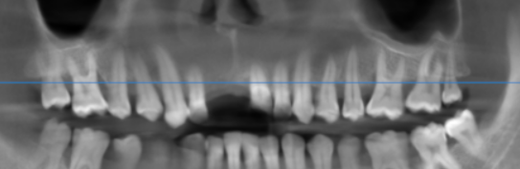

3-DIMENSIONAL VIEW

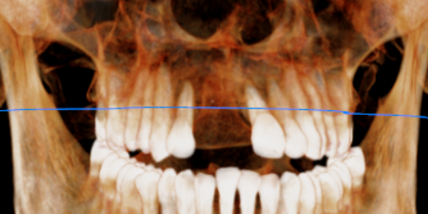

CROSS SECTIONAL VIEW

11 region | 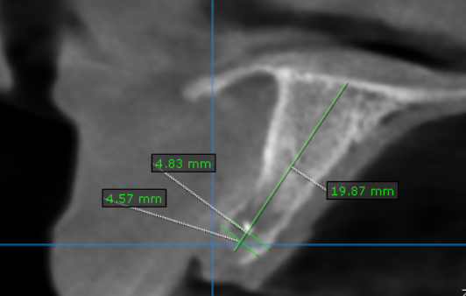

**** End of report ****

